AguaClara Documentation

Table of Contents

AguaClara Documentation 1

Introduction 2

The Technology 2

Chemical Doser 2

Rapid Mix 2

Flocculation 2

Inlet Channel 2

Sedimentation 2

Inlet Pipe 2

Slopes 2

Lamella 2

Effluent Launder 2

Drains 2

Exit Channel 2

The Process and its Limitations 2

Plant Construction 2

Materials List 2

Costs and Management 2

Initial Capital Investment Costs 2

Operation, Maintenance, and Administration Costs 2

Plant Administration and Personnel 2

Experience and Research 2

Past Plants 2

Current Research 3

# Introduction

# The Technology

## Chemical Doser

## Rapid Mix

## Flocculation

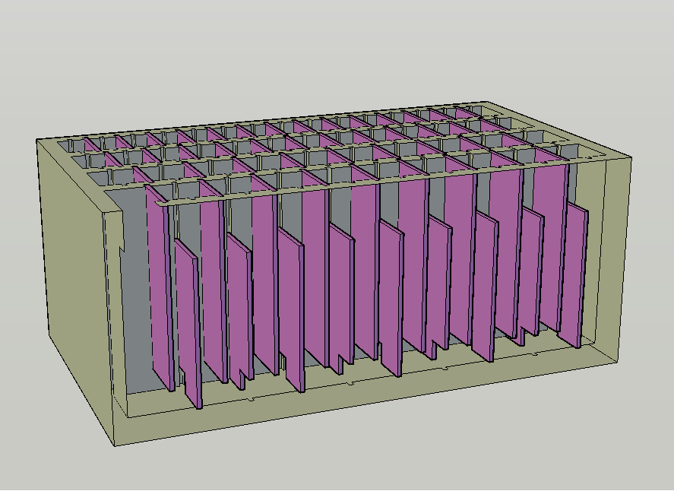

Figure **Error! No sequence specified.**. Isometric view of a vertical flow flocculator.

## Inlet Channel

## Sedimentation

### Inlet Pipe

### Slopes

### Lamella

### Effluent Launder

### Drains

## Exit Channel

# The Process and its Limitations

# Plant Construction

## Materials List

# Costs and Management

## Initial Capital Investment Costs

## Operation, Maintenance, and Administration Costs

## Plant Administration and Personnel

# Experience and Research

## Past Plants

## Current Research